Internship

  - Fall 2022

Course description
Internship
- 3 credits course

- minimum of 90 hours of internship at the internship site

- Google file to compile all the developments will be shared with

The purpose of a course is to help undergraduate students to gain practical skills related to their specializations in a real-world work setting such as in Centers for Personnel Consulting and Recruiting, HR departments, Institute for Behavioral Health and Applied Research (AUCA), National Center for Mental Health, Public Foundation/NGOs working with Parents and Children with special needs, crisis centers, schools, kindergartens or any other site which provides psychological support/services or consultation to public or specific populations. Internship experience should be in line with the student’s interest and within the goals of the program and with the student’s interest.
Within this course you will be provided with supervision and support by the internal supervisor/instructor of this course. Internal supervisor/instructor will navigate the overall internship process and internship trajectory of the student, providing necessary guidance, communicating with the internship sites in order to ensure that quality of the internship experience for the student, and evaluating the student’s progress and as trainee. The students are required to attend scheduled classes and participate at the discussion of the literature review, approaches/methods applied at different internship areas.

Objectives
Students are expected to:
- learn about major possible career opportunities, duties and responsibilities among psychologists in their workplaces;
- learn to analyze professional approaches used by psychologist in practice;
- show the ability to apply theoretical knowledge to real life situation;
- develop ability to analyze critically the work of professional psychologists, organization of
psychological support/services or HR offices.
- apply acquired research skills in practical contexts;
- be able to carry out specific professional tasks under careful supervision of external supervisor;
- develop clear vision of their career opportunities as a psychologist

Instructor: Asel Myrzabekova, Assistant Professor, Psychology
Email: myrzabekova_a@auca.kg; Office hours: by appointment via email

Internship Declaration

Students are responsible for timely provision of the Internship Declaration Form (to be filled and submitted online using this link https://forms.gle/3VXD9D9g9MUbYhrV8 ) and receive approval of the internal supervisor of the Internship site prior to starting this course.

Prerequisite courses

It is important to take into account that when selecting an internship site, you need to take the

prerequisite courses for some of them. Below you can find more detailed information on

prerequisite for some internship areas:

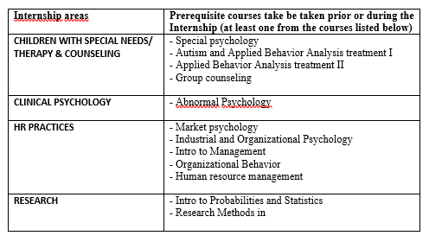

what will this course enable students to know and do?

This course allows the learner s enrolling it to achieve specific results that imporives their lives. By the end of this course you will have:
- Finalized and approved Internship report
- Finalized and approved Internship Diary
- Completed External Supervisor’s Evaluation Form
- Finalized presentation for the Internship Symposium

CLASS PARTICIPATION (in online)
- CAMERA and MIC. When attending live class meetings have your camera on whenever possible, and keep your mic on mute if you are not talking to prevent background noise. Think about your actions on camera. Always remember that everyone can see you.
- USE RAISE HAND FEATURE. To keep our conversation, open to all students, click the “Raise Hand” button to add to our class discussion.
- CONTRIBUTE VIA CHAT. Raise new topics, ideas, concerns, respond to others’ comments. Ask questions, post relevant links. The chat is a great tool to deepen our discussion!
- USE REACTIONS. A quick way to show engagement and understanding during our live meetings.
- PARTICIPATE IN BREAKOUT ROOMS. Serve as facilitator, note taker, time keeper, or reporter. Engage in the given activity, and prepare to share your discussion with the whole class.
- ADD TO CLASS NOTES. Add your perspective to a shared document (via GOOGLE DOCS, GOOGLE SHEETS and etc.) that can later serve as collaboratively created class notes or feedback and comments to your peers.
For asynchronous participation – complete class readings (individually based), engage via online discussion (discussion boards – using PADLET, JAMBOARD) and ask for help by reaching out to your internal/external supervisors and/or classmates with question or concerns about the content, assignments, or course management. You can email your internal supervisors, book an online meeting with your internal supervisors.

Assessement and evaluation of students
Grading system within this class is based on either Passing the course or Failing (Non-Pass). The following 1-6 milestones must be fulfilled by the student within the Fall semester. In Spring 2022 each students needs to present their internship at the Internship Symposium.
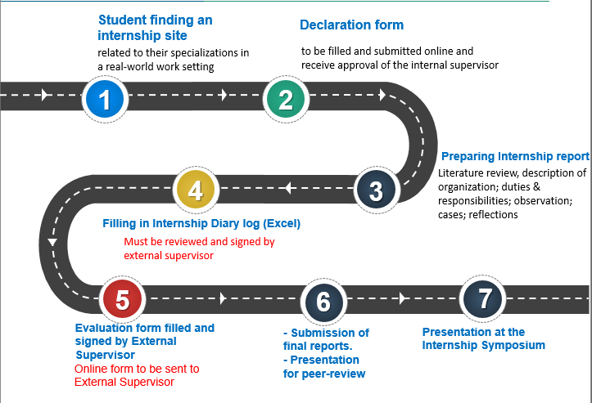

Check your email (Gmail – AUCA) and use e-course on regular basis. Additional reading materials and study guides will be posted via electronic course system/Google folder.
It is strongly recommended consider necessary precautions for both students, external/internal internship supervisors, and other staff/clients – wear masks, use sanitizers during offline meetings, keep distance 1.5-2 meters. Stay safe and healthy.

Resources available at the university
All students are encouraged to use the available resources that are offered by the university, particularly you are advised to use the databases, open access resources available via the services provided by AUCA Library. As well as you are strongly encouraged to approach the Writing and Academic Resource Center (WARC). WARC offers one-on-one tutoring sessions in a variety of subjects, including writing and English language Help. You can make your reservation at warc.auca.kg. In addition to this you can approach for help to obtain guidance on courses and study requirements to Academic Advising Office - https://auca.kg/en/academic_advising/. AUCA also offers professional psychological support for students where they can ask for help through Psychological Counseling Services - https://auca.kg/en/psycons/. All discussed issues at the Psychological Counseling office will be completely confidential and services provided in a supportive and friendly environment.

